1. First, we made a new middleware file to export our auth

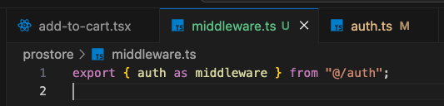

This was necessary as this is the next js default convention

1. And we added the authorized callback to our auth

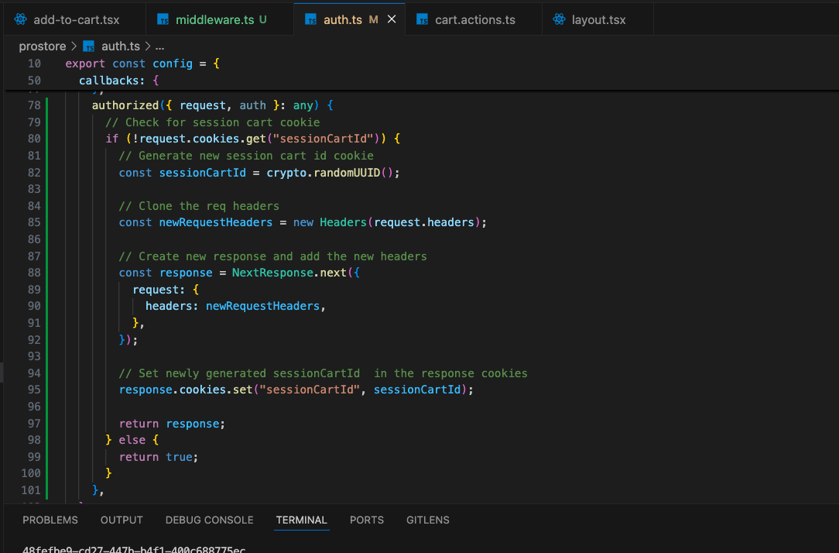

We could have just used local storage to handle the cart of the guest. But we are using the cookie this time to generate the session ID to match that of the guest user with the authorized one.